**The Steps I've Taken To Set Up My Developer Environment.**

**Your Operating System (OS)**

**Step 1: Download Windows 11**

* Went to <https://www.microsoft.com/software-download/windows11>
* Before installing,I refereed to the PC Health Check app to confirm if my device meets the minimum system requirements for Windows 11.

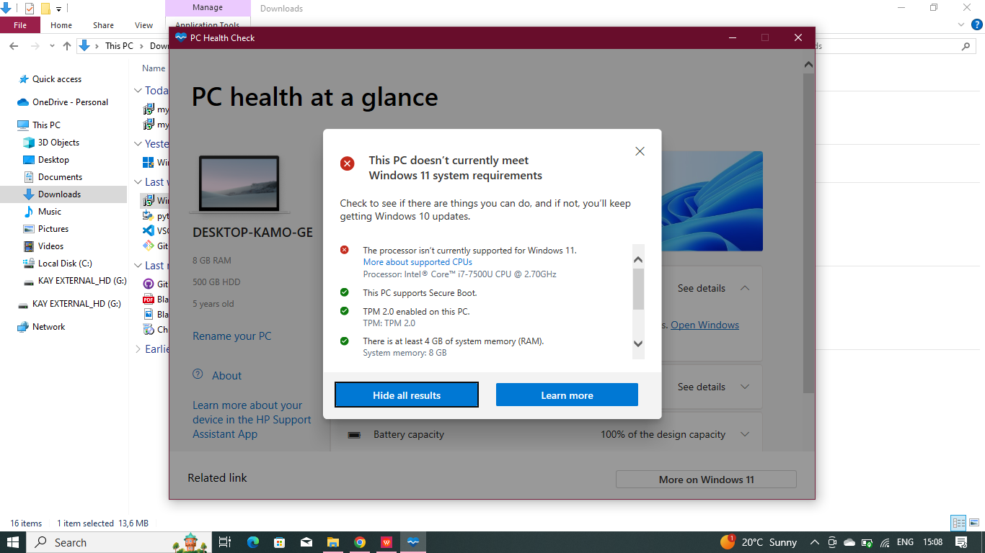

* I learnt that my PC does not meet the Windows 11 system requirement.
* Clicked “Learn More” then…

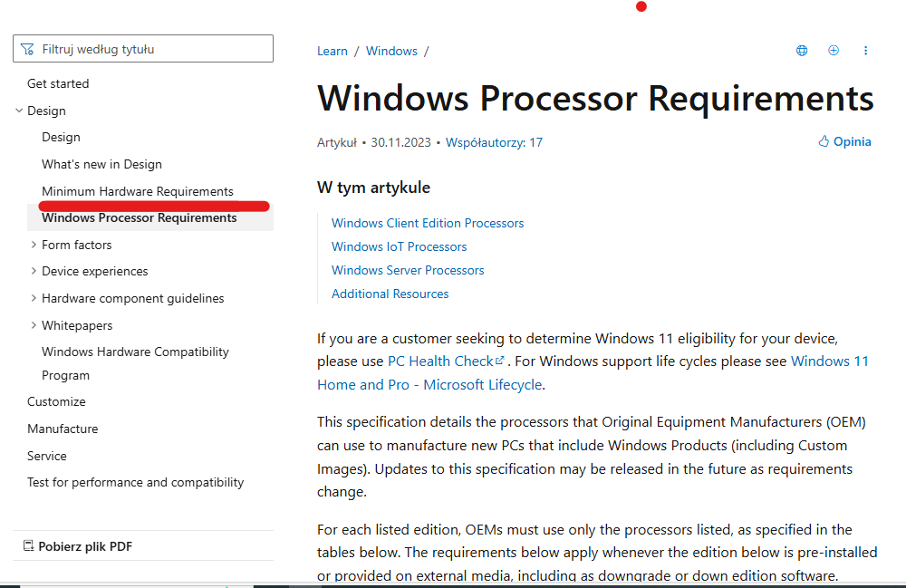

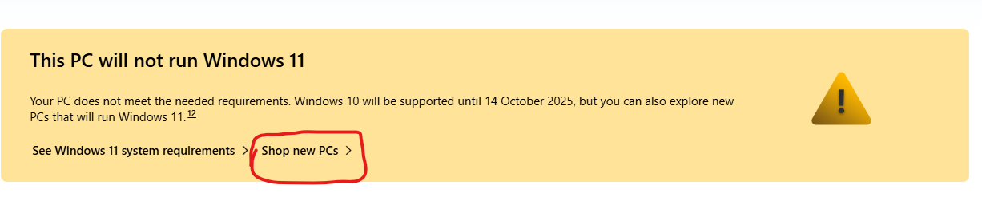

**Visual Studio Code.**

**Step 1: Download Visual Studio Code.**

* Went to <https://code.visualstudio.com/Download>

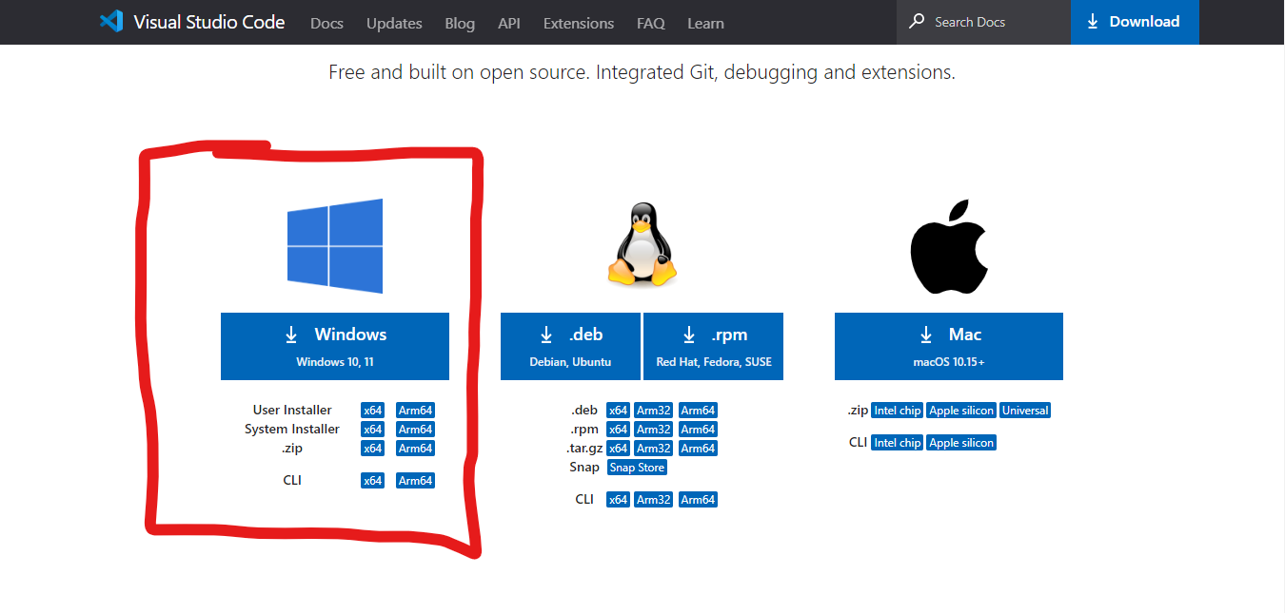

* When it was done downloading, I then installed
* I then set it up using the guideline provided at above given link.

**GitHub**

**Step 1: Download GitHub**

* Went to [https://github.com](https://github.com/)
* Created an account, entering my email address and created a password.

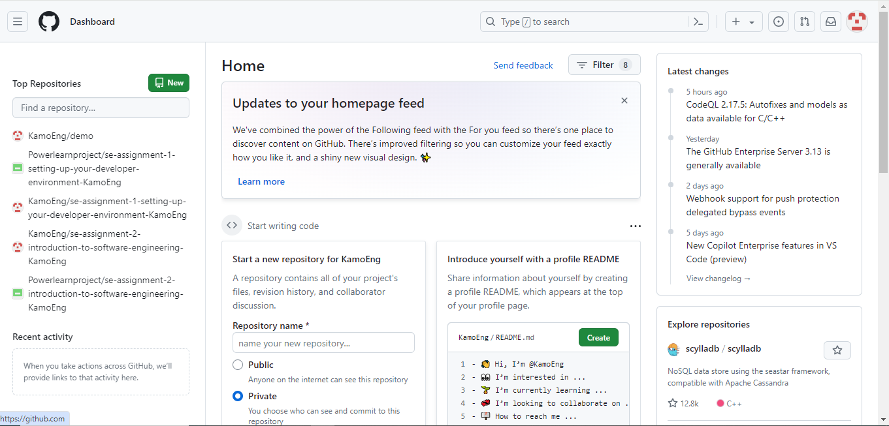

**Python**

**Step download: Python**

* Went to [http://wwww.python.org](http://wwww.python.org/)
* Downloaded the latest version, then…

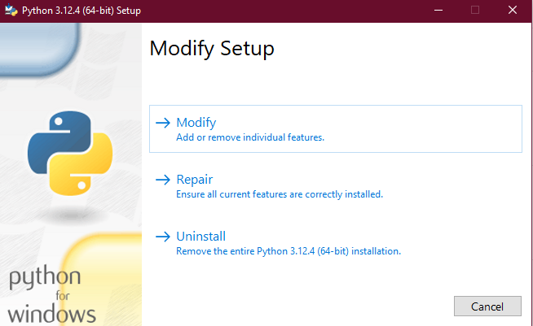

Set it up.

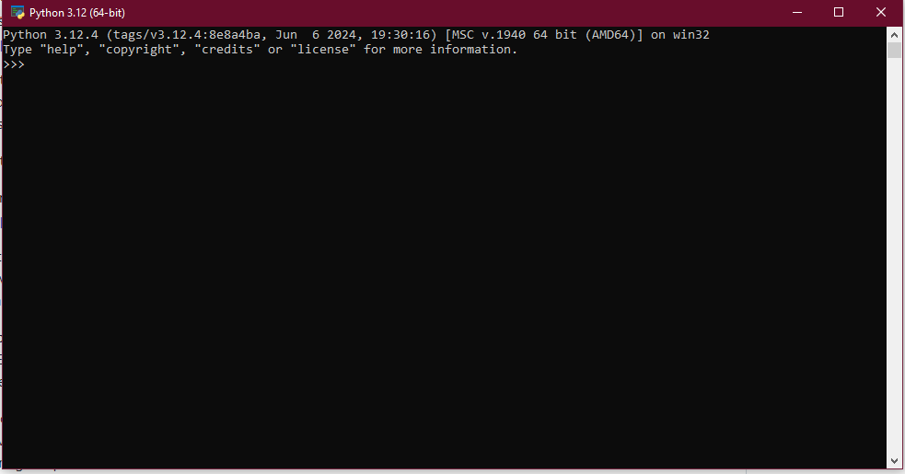

Its all system Go.

**MySQL**

**Step 1: Download MySQL**

* Went to <https://dev.mysql.com/downloads/windows/installer/5.7.html>
* Downloaded the latest version

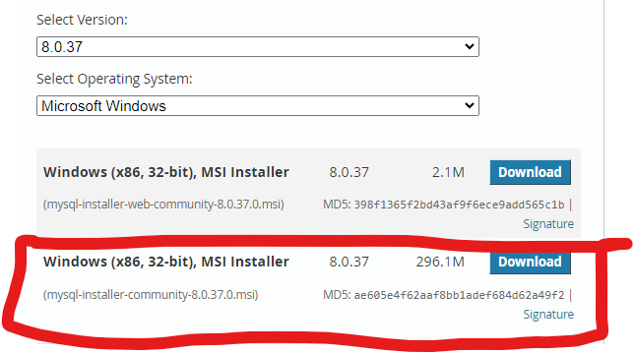

* After downloading, I then checked where its loacated

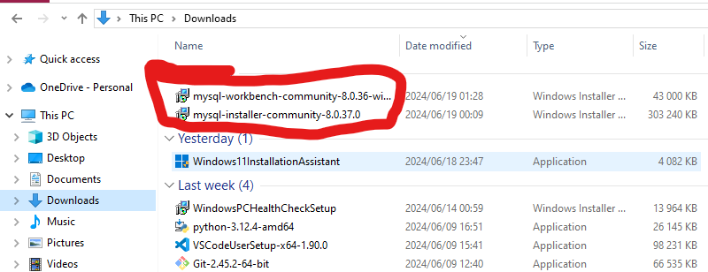

* Then set it up

